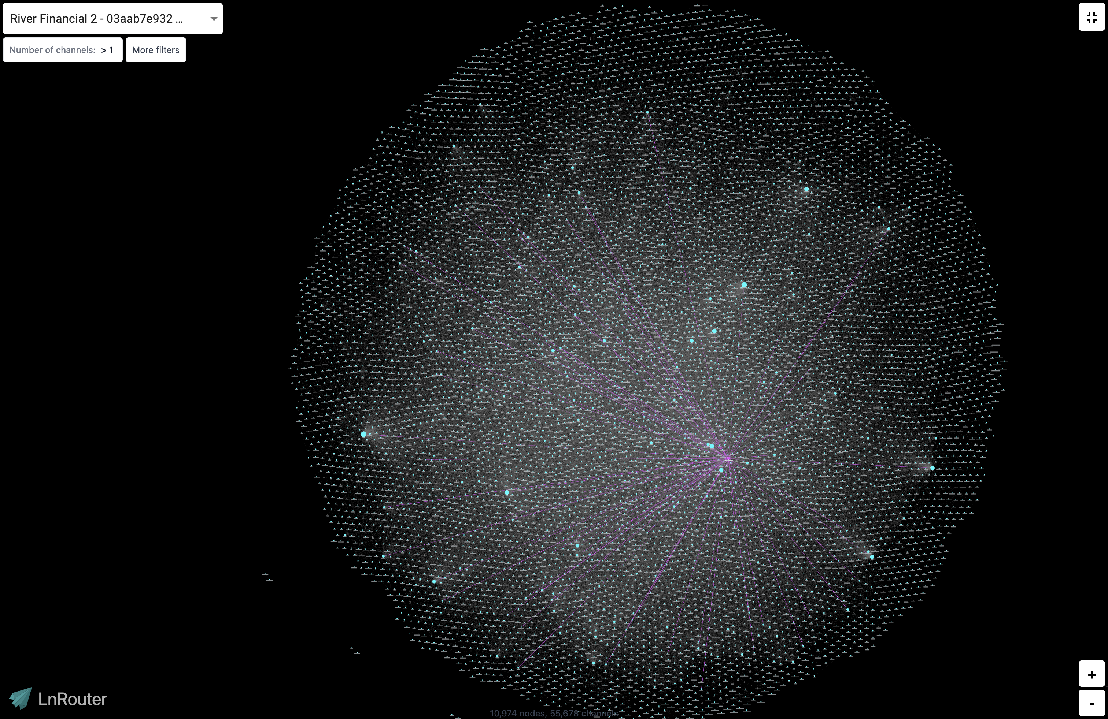



BTC Treasury Pilot

for [Company]

Pilot an internal treasury with Bitcoin (BTC) asset self-custody.

BTC01A23

Version 1.0

Contents

01 Bitcoin Overview

02 [Company] Objectives

03 Proposed Solution & Project Details

04 Team Structure and Responsibilities

Exhibits

Agreements

Date of proposal

**December 1, 2023**

Bitcoin protocol terms valid forever.

Contact:

**[Your Name] Thayer**

[Company]’s Internal Bitcoin Expert

01

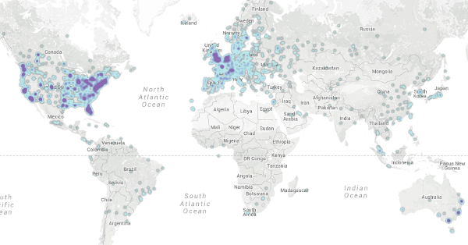

Bitcoin Overview

Founded in 2008, Bitcoin, the peer-to-peer, open-source software protocol, is disrupting the world’s financial system. Bitcoin has a 15-year track record helping people and companies outperform inflation, protect wealth, avoid third-party risks, and grow wealth by investing early in the future world reserve currency.

*[Establish a commonality between Bitcoin & the foundational philosophy of the company]*

*[Example:] While Satoshi is the inventor, the true pioneers are the same luminaries of the innovation theories [Company] promotes today. Henry Ford called for a currency backed by energy. The Austrian Economists who promoted ideas like “aims to achieve” (Human Action, 1963) and “prioritizing needs by importance and satisfaction” (Principles of Economics, 1871) also wrote extensively about the flaws of fiat currencies. In 1997, Davidson predicted that “in the new millennium, cybermoney controlled by private markets will supersede fiat money issued by governments”. And in 2021, [CEO’s Name] wrote “…”. If Bitcoin does in fact get this job done better, than according to [Company’s philosophy] it’s adoption will continue.*

Bitcoin is a fully [open-source project](https://github.com/bitcoin) that yields an inflation rate of zero and a cryptographic security with a key-space of 2256. In other words, stealing someone’s Bitcoin is roughly as hard as guessing a single atom in the known universe. Today, two countries use Bitcoin as legal tender, over one-half of the Fortune 100 have pursued “crypto” initiatives, over 80% of institutional investors have exposure or are considering adding it to their portfolios, and a dozen Bitcoin ETFs are likely to be launched within the next few months. Bitcoin’s nodes span 76 countries across every continent including Antarctica and in orbit. To learn more about Bitcoin’s unique value proposition and track record you can visit [hope.com](http://hope.com/)

Bitcoin is based on the theory that people “hire” money to get a “job” done and that they have a list of metrics to evaluate success when intermediating the storage and exchange of value. While we don’t have an internal study to reference, there is a deep body of literature on key characteristics that all monies have to varying degrees including: durability, portability, divisibility, fungibility, and limited supply. These characteristics form the basis for assessing different monetary options.

Everyone is underserved to varying degrees by today’s fiat currencies and other stores of wealth. Inflation, bank runs, systemic risk, hacking, human error, and political uncertainty have been on the rise. By possessing both superior store-of-value properties than gold and superior medium-of-exchange properties than ACH and Visa, Bitcoin offers companies a unique opportunity for their treasuries. Given [Your Name]’s expertise on this subject, [Company] has a rare opportunity to pilot a Bitcoin treasury to better protect long-term savings against financial risks while also yielding a higher rate-of-return than alternative options.

02



[Company] Objectives

[Company] recognizes the critical importance of cashflow management in securing short and long-term business operations. When leadership sets aside money for savings, they need to determine which method for saving money will best preserve it while maintain liquidity for ongoing operations. Owning stocks, bonds, or equity in the ventures [Company] serves is a high-risk endeavor that falls outside of the core mission and capabilities of the company. As the current world reserve currency, the United States Dollar currently has one of the lowest inflation rates and the best liquidity compared to other fiat currencies. Thus, it has been the natural choice as a savings vehicle for [Company]’s assets.

However, this convenience comes at a cost. Ongoing money creation by the US Federal Reserve continually dilutes the money supply, effectively imposing a fee on savers. For example, on a fund of $500,000, a 5% inflation rate costs $25,000 per year. Furthermore, dollar funds are traditionally stored with third parties. With the increasing occurrence of bank-runs and capital controls imposed in a volatile economy, this ongoing cost may not be purchasing as much safety as it has in the past. [Company] is well aware of this and understands implications of their treasury strategy.

To reduce the costs of inflation, mitigate the risks of reliance on third-parties, reduce the volatility of the treasury valuation, and benefit from a higher rate-of-return, [Your Name] is proposing the following:

1. Leadership discusses the idea of holding Bitcoin on their treasury balance sheet.
2. [Company] pilots the Bitcoin treasury approach with a small amount.
3. [Company] monitors the performance of the Bitcoin treasury on a quarterly basis.

Given [Company]’s vast expertise in [unique capability of company], we are in a unique position to recognize and take advantage of a financial innovation prior to adoption by competitors. This initiative will better position [Company]’s treasury strategy to protect and grow its assets over time in an increasing uncertain economic environment.

03

Proposed Solution

As part of the **BTC Treasury Pilot**, [Your Name] will help [Company] execute the following:

Determine whether this strategy is worth considering and pursing

Hold internal discussions with key leadership individuals to determine whether any further consideration should be given to this idea. If so, then debate the pros and cons and make a final determination about whether to proceed with the following steps.



1

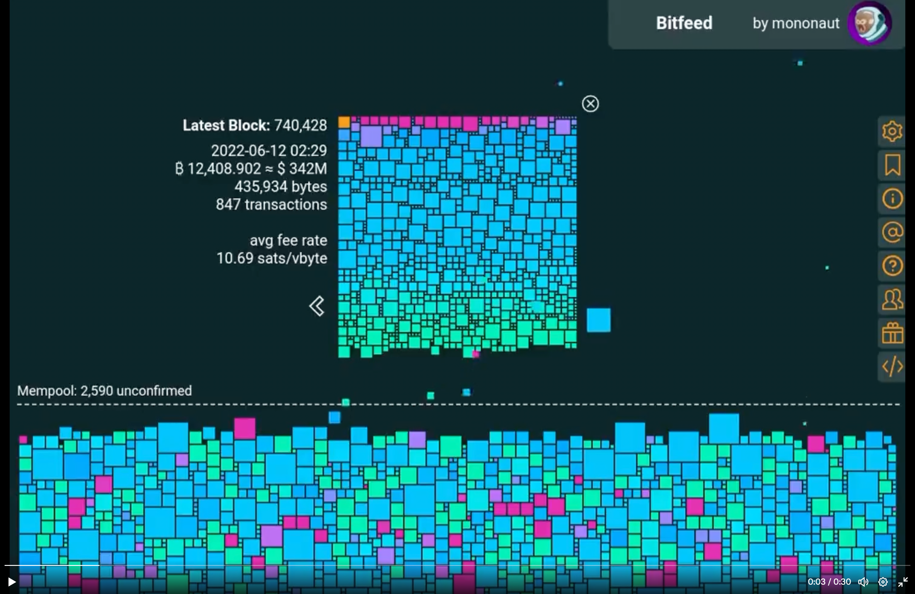

Prepare to acquire and custody the asset

There are three elements to successfully acquiring and holding Bitcoin: fundamentals education, an exchange account, and a custody solution. [Your Name] can either complete all portions on [Company]’s behalf or guide [CFO’s Name] through the process. [Company] will maintain full ownership and control over the Bitcoin once stored.

**2**

**5**

**4**

**3**

Acquire the asset

[Company] would need to fund the company’s exchange account in order to purchase the asset. The amount to be acquired is completely up to [Company] leadership. There are educational and preparatory benefits to small amounts and financial returns for more substantial amounts.



Custody the asset

Taking custody of Bitcoin is a critical step of the process. While third-party companies can provide this service to [Company], [Your Name] recommends self-custody. [Your Name] can execute this step or guide [CFO’s Name] through the process.

Monitor and modify the strategy

Once is custody, Bitcoin is entirely safe and does not require further monitoring. However, checking in on it yearly is a good idea for purpose of practice. Bitcoin is liquid and can be bought or sold at any time.

**PROCCESS EXECUTION DETAILS**

As part of the **BTC Treasury Pilot**, [Your Name] and Leadership will assist with the following steps:



|  |  |  |
| --- | --- | --- |
| **1** | **DECISION-MAKING PROCESS** | **Activities:**  [Company] may understand that there is some need to improve their asset allocations during periods of high inflation and banking instability. However, they want to evaluate Bitcoin accurately to determine if it will achieve their financial needs. [Your Name] will lead a conversations and Q&A session with leadership and compile citation resources to address all questions [Company] has. [Your Name] can also suggest a number of professional advisory services should [Company] seek external council.  **Deliverables:**  At the end of deliberations, leadership should decide the following:   1. Whether or not to proceed with acquiring a nominal amount of BTC 2. If the plan, as described below, will work for the company 3. What amount to initially allocate to the asset |
| **2** | **PREPARATION**  **PROCESS** | **Activities:**  In order to set the stage for Bitcoin acquisition, leadership, particularly [CFO’s Name], will want an understanding of Bitcoin fundamentals is and how it works. [Your Name] can provide this as part of the discussions above and has compiled a set of educational material as well.  Next, [Company] will need an account established with an exchange. [Your Name] can either do this as a [Company] representative or walk [CFO’s Name] through the process. [Company] will have to comply with KYC/AML regulations which may take a couple of days for the account opening process to complete.  Lastly, [Company] will need a custody solution to store the Bitcoin safely. [Your Name] recommends a two-part solution comprising a hardware wallet (described below) as well as two copies of the seed phrase (backup key). One copy can be held by [CFO’s Name], and the other copy can be held by [CEO’s Name]. Alternatively, a bank could hold one of the keys. [Your Name] can handle the technical setup of this structure with [CFO’s Name] observing or provide remote guidance.  **Deliverables:**   1. Baseline fundamental educational knowledge of Bitcoin 2. An active exchange account for [Company] 3. A “cold storage” custody solution for [Company]’s Bitcoin |
| **3** | **ACQUISITION**  **PROCESS** | **Activities:**  Once preparation is complete, [Company] will be able to begin acquiring the desired amount. First, [Company] will have to fund the exchange. Depending on the amount to acquire, [Your Name] may advise doing it piecemeal to mitigate risk. After acquisition, it will take some number of days for the USD balance to settle before the Bitcoin can be withdrawn into self-custody. Leadership may find it tempting to simply leave the Bitcoin balance held on the exchange – [Your Name] strongly advises against this and recommends a self-custody solution detailed below.  **Deliverables:**  [Company] will have an account with an exchange as well as the asset on the exchange. |
| **4** | **CUSTODY**  **PROCESS** | **Activities:**  In order to ensure safekeeping of the asset, the Bitcoin should be withdrawn from the exchange and held using a Cold Storage Hardware Wallet. The transfer will settle in less than 1 hour and will be entirely irreversible. As part of setting up the hardware wallet, [Company] leadership will be in possession of a seed phrase written on some medium. That seed phrase should never be revealed to any person or digital device including but not limited to: pictures, videos, Alexa, computers etc. The seed phrase can be used at any point in the future to back up and gain control over the Bitcoin position held in the wallet. When applying proper custody procedures, the Bitcoin held in [Company]’s wallet is completely safe from outside threats.  **Deliverables:**  Bitcoin held in cold storage. |
| **5** | **MANAGEMENT PROCESS** | **Activities:**  Over time, [Company] may decide to either acquire additional Bitcoin or dispense with the Bitcoin already purchased. The exchange account used before will serve as the intermediary between their Bitcoin balance and their USD balance in their bank account. Bitcoin is highly liquid when sold and USD funds are often available same-day if rapid liquidity is needed. Furthermore, [CFO’s Name] can track the USD value of the Bitcoin held easily using a publicly available blockchain explorer – searching the public key of [Company]’s Bitcoin wallet. If no changes are made to the Bitcoin strategy or position, no management or upkeep is required. |



04

Team Structure and Responsibilities

Due to the novelty of this approach, the following team structures is recommended:

* [Your Name] leading the process and providing general advisory or support as needed
* [Your Name] and [CFO’s Name] executing the process on [Company]’s behalf
* [CFO’s Name] tracking the balance annually to observe the impact on [Company]’s balance sheet
* [CFO’s Name] and [CEO’s Name] physically holding the seed phrases
* Rob as an internal reference on the approach if needed

**EXHIBIT A: COST**

Because Bitcoin is a liquid asset, amounts invested remain accessible to [Company] operations if needed. When establishing the initial treasury, [Company] will incur minimal overhead expenses. The numbers provided below are representative to assess the total opportunity cost to the organization.

|  |  |  |  |  |
| --- | --- | --- | --- | --- |
| ITEM | **QUANTITY** | **UNIT COST** | | **COST (USD)** |
| Estimated Total Hours | 10 hours | | $500 | $5,000 |
| Estimated Fees from Exchange Acquisition |  | | 1% | TBD |
| Self-Custody Storage Device |  | | $100 | $100 |
| Seed Backup |  | | $100 | $100 |
| Bitcoin (see below) | TBD | | $35,000 | TBD |
| **Total Overhead** |  | |  | **$5,200 + Fees** |

Note: In the past 10 years Bitcoin has obtained a 42% compound annual return with a 78% standard deviation. See the non-inflation-adjusted USD price history below for reference:

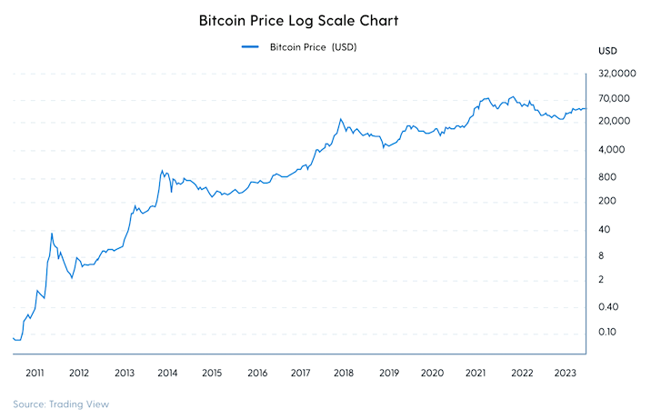

**EXHIBIT B:**

**[Your Name]**

**[Company]’s Internal Bitcoin Expert**

[Your Name] has over X years investing and actively participating in Bitcoin communities. He has personally adopted and helped many others adopt a Bitcoin allocation for the first time. He is an active operator of a top X node on Bitcoin’s Lightning Network and has attended Bitcoin conferences across XYZ. [Add your additional Bitcoin credentials here]. As one of the world’s only experts on both Bitcoin and [Company-unique subject], he is uniquely positioned to execute and support [Company]’s Bitcoin treasury should they choose to pilot the approach.